Artifacts created

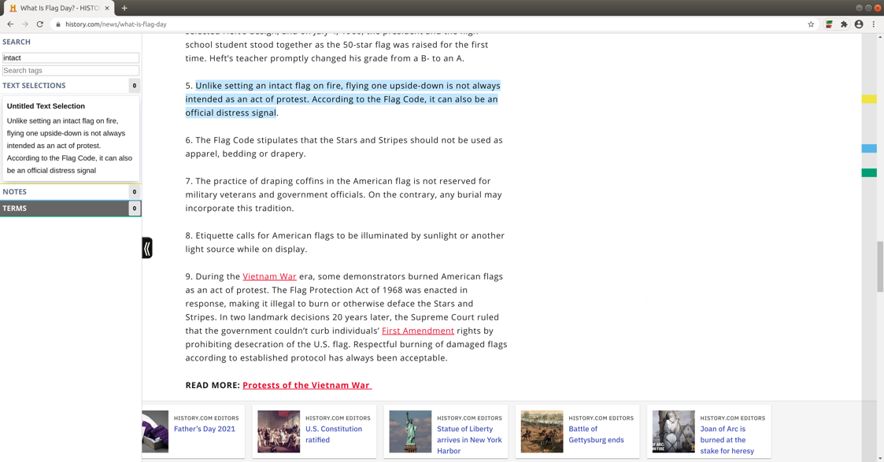

Handle

Search

Number of selections